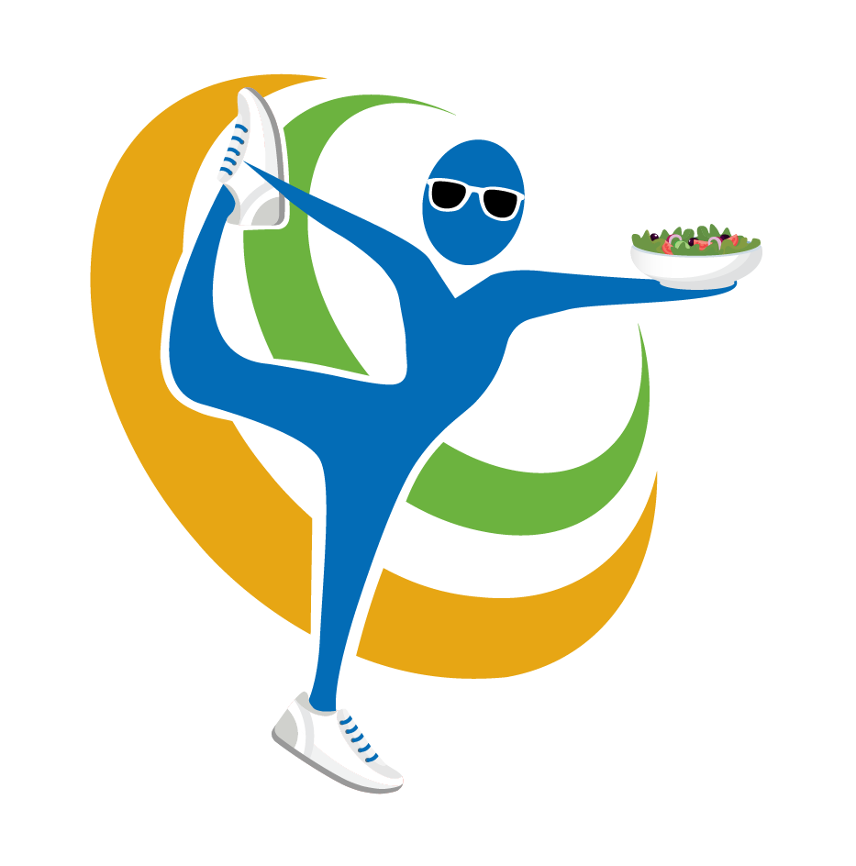
Cookbook Price $20
Chicken Sausage & Veggie Quiche
Cage-free eggs, Italian chicken sausage, mushrooms, green onions, bell peppers, and Asiago cheese on organic pie crust
Cage-free eggs, feta cheese, spinach, tomatoes on organic pie crust

Hempseeds
Spinach Feta Quiche
These nutty & delicious superseeds are super rich in protein (11 grams of protein in just 3 Tbsp)

Build Your Own Parfait

Traverse City Cherry Granola
Cacao Nibs
Shredded Coconut Honey Flax Energy Bites
Oats, coconut, pecans, dried cherries, flaxseeds, maple syrup, coconut oil, honey, vanilla extract
Raw unprocessed form of dark chocolate--high in calming magnesium
The medium chain fatty acids found in coconut help to improve metabolism and energy.

Featured Recipes from
Target To Table: Healthy & Delicious Meals One Superfood At A Time
Author: Kristen Johnson Brogan, Registered Dietitian & Superfood Chef

Honey Flax Energy Bites
Nut Milk
Nut milks are nutrient rich and tend to be easier to absorb and digest than cow’s milk.
Oats, almond butter, honey, flaxseeds, vanilla extract, cacao nibs

Fruitilicious Upside Down Cake
Date- pecan crust with fresh berries
Black Bean Mango Salsa
Black beans, organic corn, bell peppers, avocado, mango, and green onions with lime balsamic vinaigrette

